**ASSIGNMENT-2**

**Deriving a Decision Tree from Given Dataset:**

Step-1 : Open the given Dataset in Weka Here we are considering German Credit Dataset.

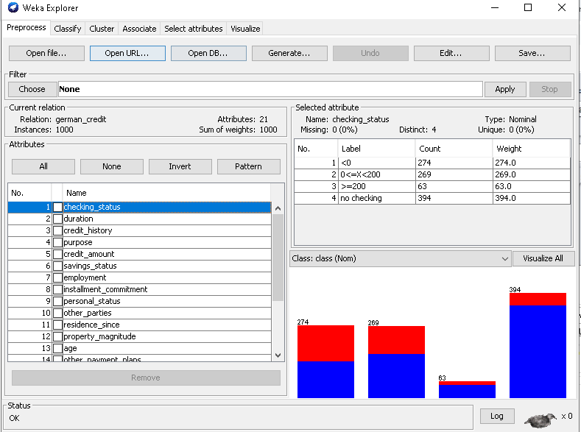

Step-2 : Click on classify tab. Click on choose and select the J48 from trees.

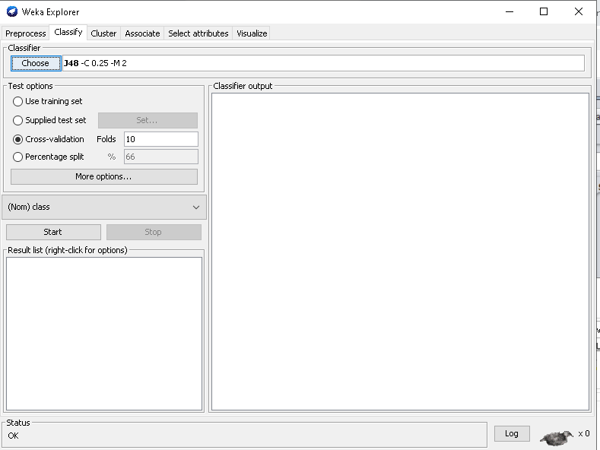

Step-3: Now select Use training set and choose class from dropdown list.

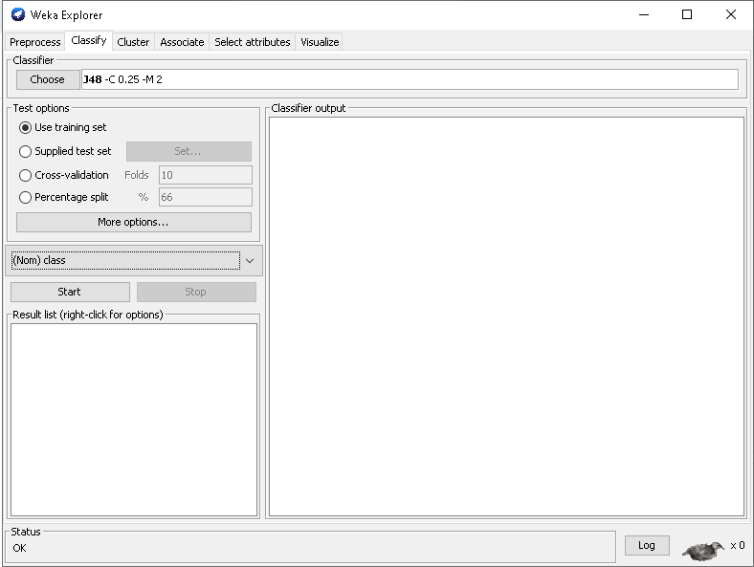

Step-4: Click on start. We will get the output as below.

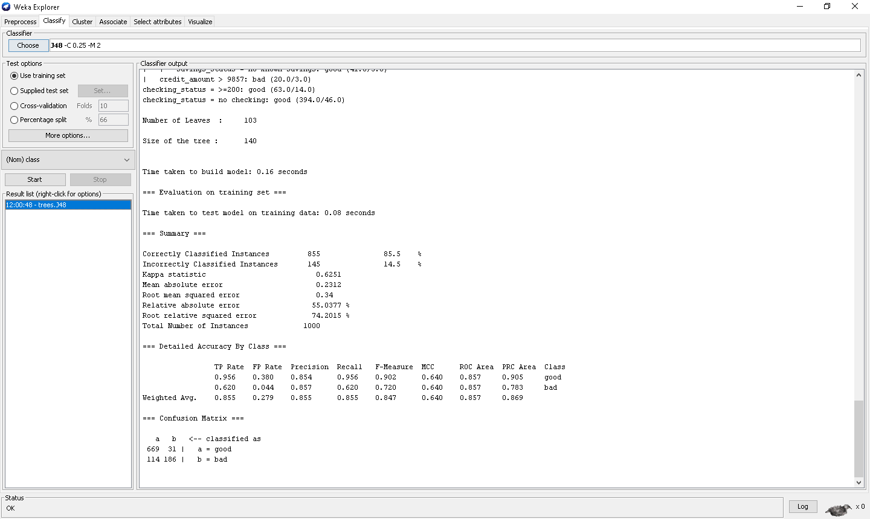

Number of leaves = 103

Number of tree = 140

Time taken to build Model = 0.3 sec.

Step-5:we also get the confusion matrix as below.

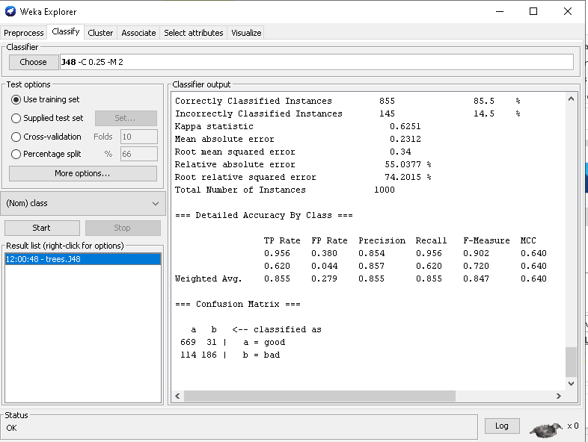

Step-6: Right click on the option in the result list and select the visualize tree option. Then we get the tree as shown in below.

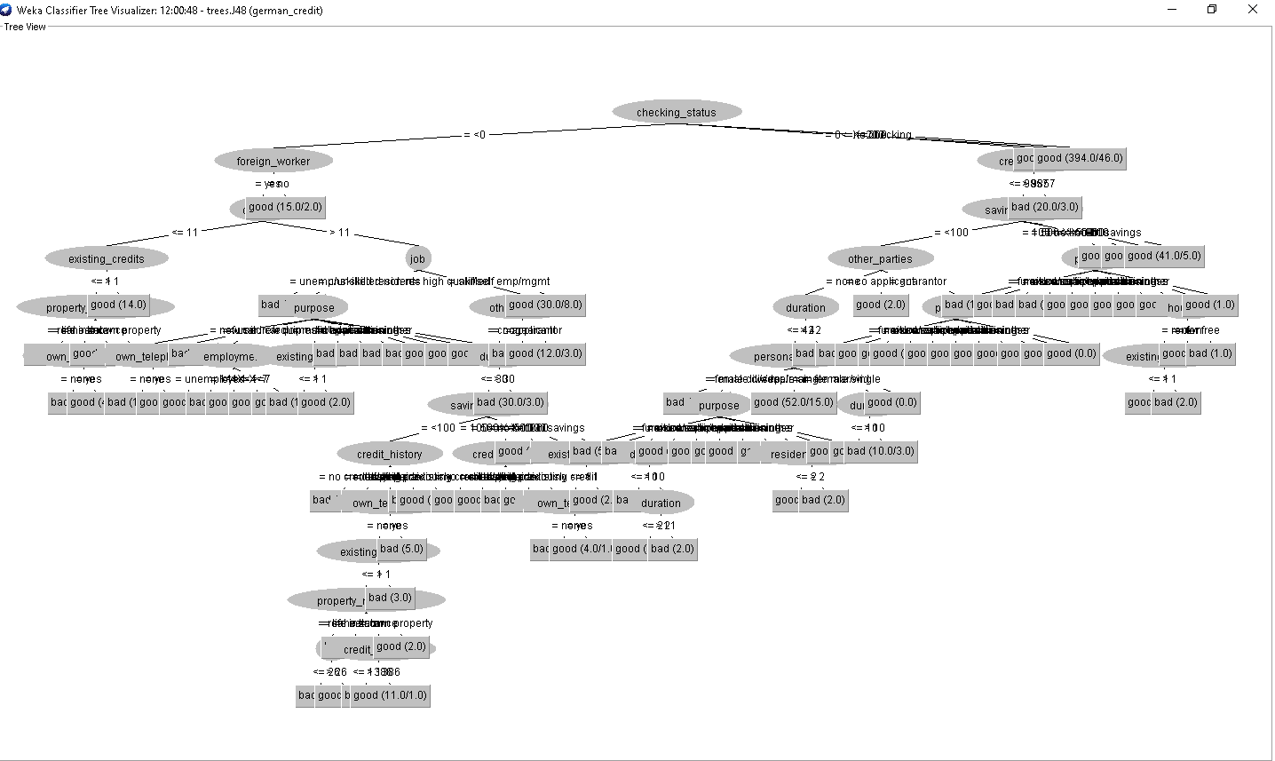

**Varying the percentage split for accuracy:**

1. **For J48 classifier:**

Accuracy when percentage split is 66%.

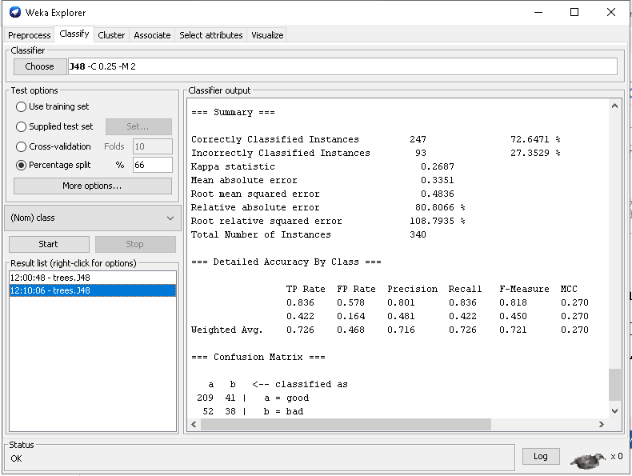

Accuracy when the percentage is 80%

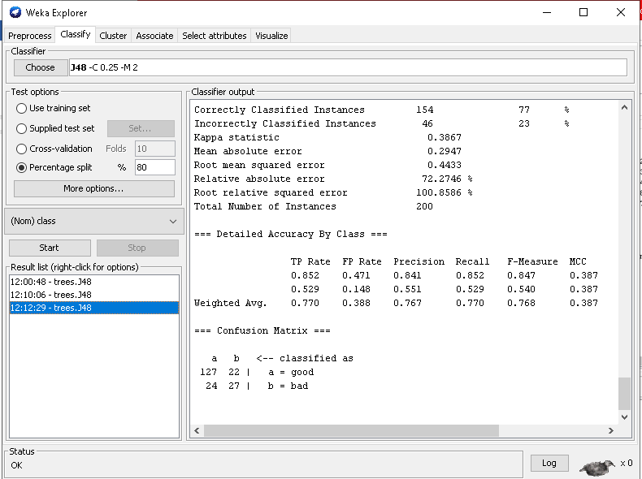

1. **FOR NAIVEBAYES CLASSIFIER:**

Accuracy when percentage split is 66%

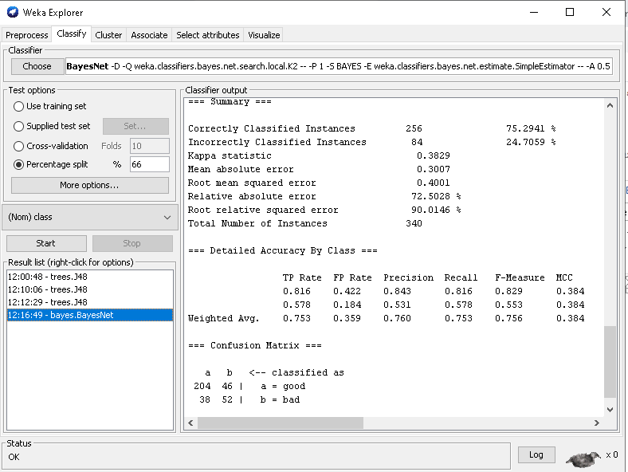

Accuracy when percentage split is 80%.

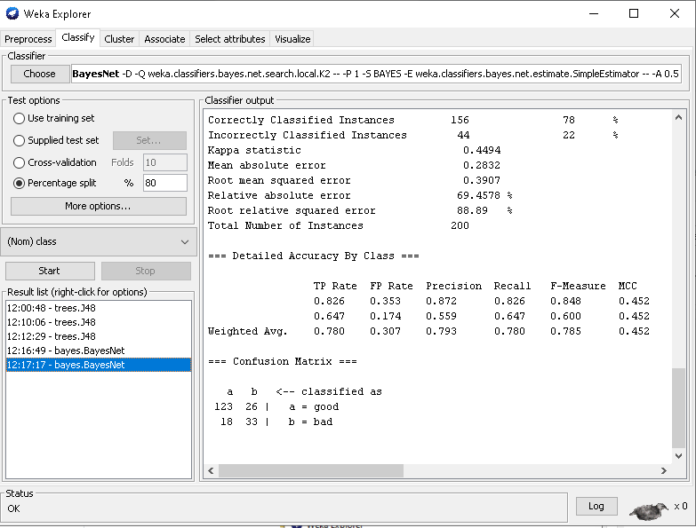

**Varying the cross validations for accuracy:**

1. For J48 Classifier:

Accuracy when cross-validation folds = 10

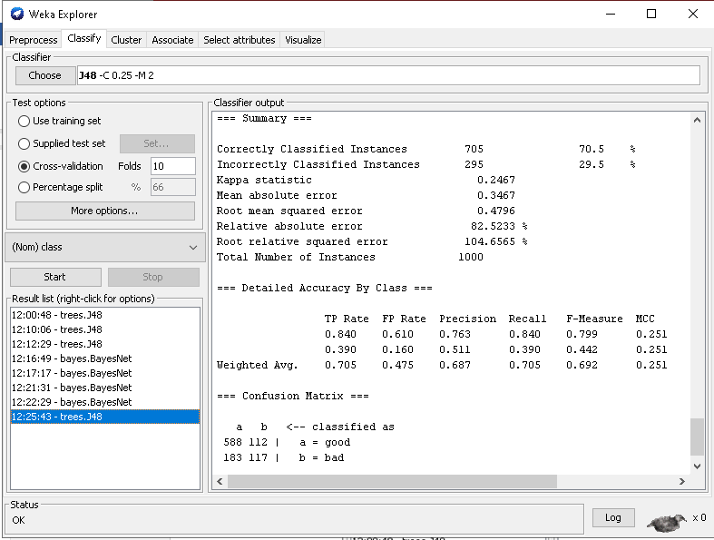

Accuracy when cross-validation folds = 7

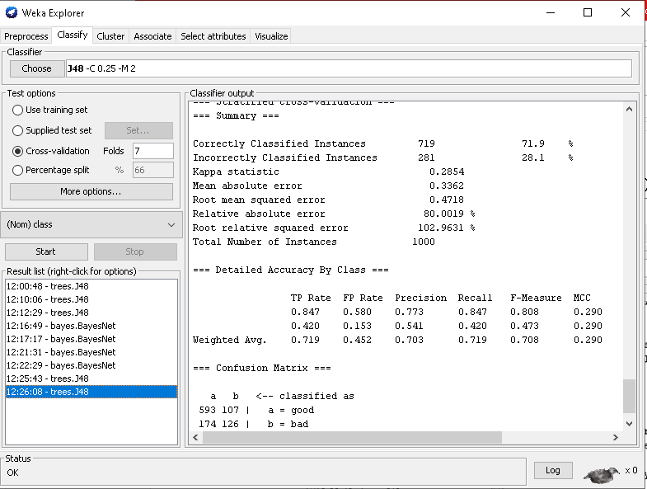

1. **FOR NAIVEBAYES CLASSIFIER:**

Accuracy when Cross – validation is 10.

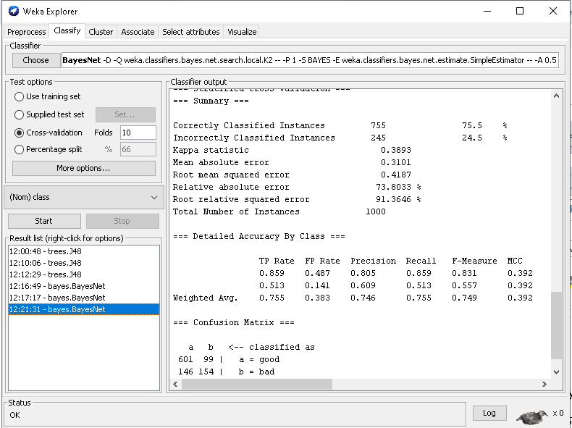

Accuracy when Cross – validation is 7.

